|  |
| --- |
| **ASIA PACIFIC COLLEGE**  School of Computer Science and Information  Technology  JMGTCC  Travel Arrangement & Appointment System |
| User Manual |
|  |
| **Arianne Bianca F. Papa**  **Erika C. Hidalgo**  **Roxanne Therese A. Lanugo**  **IT 111** |
| **A.Y. 2014 - 2015** |

**Mr. Jose Eugenio Quesada**

Professor

Table of Contents

Introduction 2

User Groups 2

Basic Buttons 2

System Modules 3

Maintenance Modules 4

Appointment Scheduler 7

Create a new Appointment 7

Update an Existing Appointment 7

Confirmation of Appointment (Backend) 10

Travel & Tour Arrangement 11

Create Travel & Tour Arrangement 11

Viewing of Arrangement Made (Backend) 14

Customer Service 15



# Introduction

Journeys & More Global Tours and Consultancy Co. (JMGTCC) Travel Arrangement and Appointment System is an application that enables clients of JMGTCC to create their own travel detail arrangement and for the application guests to schedule an appointment for visa assistance instead of relying on the travel agents of the agency to cater the basic needs of their clients.

# User Groups

**Admin/Encoder** is the person in charge of maintaining the system, managing all the travel arrangement records and appointment records and the one who has complete access with both the backend and frontend perspective of the system. The admin is the one who can update and add record to the system for all the maintenance modules or the dynamic values that clients or frontend users select from.

**Registered Clients** are the users who has full on access on the frontend side of the system. They create travel arrangements and visa appointment.

**Guests** are users who haven’t signed up on the site, though they can view the frontend of the system. The only feature that the guests can access is visa appointment and customer support.

# Basic Buttons

All icons listed below are basic buttons that can usually found in grid tables of the system.

|  |  |  |
| --- | --- | --- |
| **Icon** | **Button Name** | **Description** |
|  | View Button | This button redirects the user to a page wherein users can view the details of a single record. |
|  | Edit Button | This button allows users to edit or modify a specific record. |
|  | Delete Button | This button is used to delete records and wipe out the record in the system. |

# System Modules

The System modules are the following:

* **Maintenance Modules**

The maintenance module contains 7 sub modules namely Airlines, Food Deals, Freebies, Time, Tour Type, Transport Service and Personnel. The modules under this are controllable modules that the admin can modify and in turn affects the frontend forms wherein clients select from.

* **Appointment Scheduler (Visa Assistance)**

In the customer module of the system, clients can have access to the system in case they want to schedule a Visa Assistance Appointment with the General Manager.  They will input their name, email address, phone number, appointment time and day and optional remarks or message.

* **Travel & Tour Arrangement**

The Client inputs necessary details about the travel packages he wants to avail. He can choose from the list of travel packages offered by the agency or request for a new travel package-combination or arrangement.

* **Customer Service / Technical Support**

This is an online chat support feature that enables the clients of JMGTCC to communicate with the company IT Support Team through the application.  The client can send a direct / instant message about technical concerns to the IT Support Team.

# 

# Maintenance Modules

Maintaining the System

To make sure that the system stays up to date and the information in the frontend are updated, the maintenance modules should be constantly updated by the admin. The seven maintenance modules can be found in the backend/admin side of the system and located at the left side of the home page.

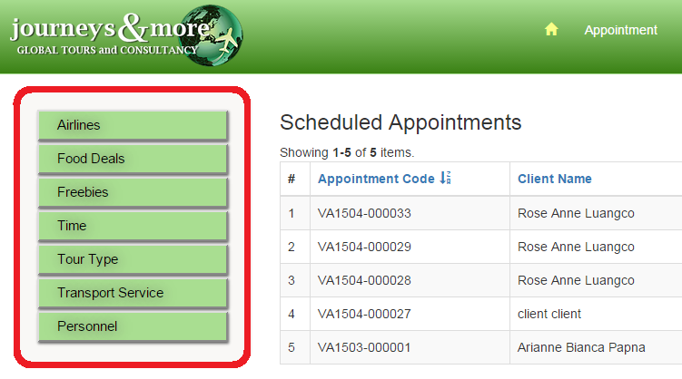

To start updating simply click on one of the buttons and it will redirect to the index page of the chosen sub module. All sub-modules under the maintenance modules has the same process the only difference the values and the purpose of each and on what form they are accessible in the frontend.

Here is a step by step example for the Food Deals of how to manage one of the sub-modules:

1. 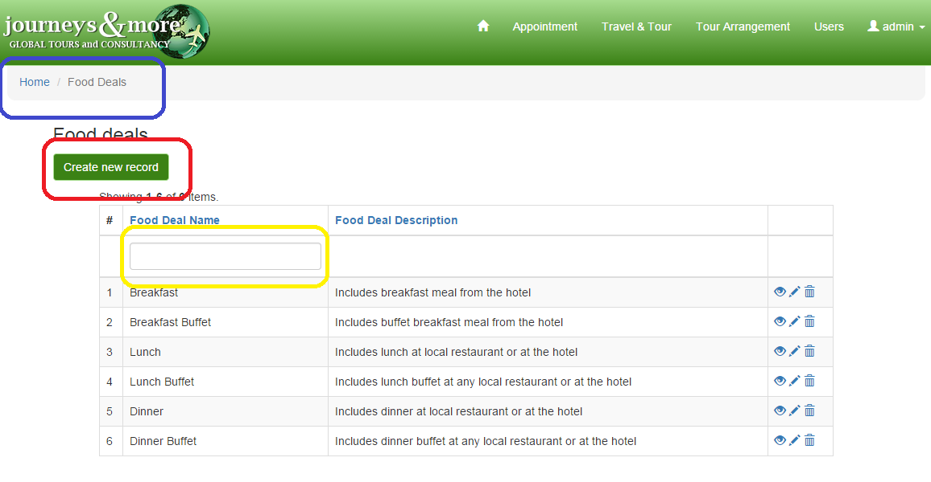Familiarizing with the modules index page

The index page of every module display the same as what is in the diagram. The index page basically contains the grid table containing the records and the basic buttons which are described in the *Basic Buttons* section of this manual. The following are some of the main parts of the page to remember.

1. The **breadcrumb** is illustrated in the diagram above in a **blue mark**. It works like a root directory of a system file and it determines whether on what part of the system you are in.
2. The **create new button** is illustrated in the diagram above in **red mark.** This is used to add or create a new record for the module that you are in.
3. The **search box** is illustrated above in the diagram in **yellow mark**. This text boxes are used as an engine to search for any existing records with a use of a search key or term/word that the user wants to look for.
4. Creating a new record

After clicking create new button in the previous step, the system will redirect to a form wherein the new record details will be validated. After the forms has been filled up simply click the create button located at the bottom of the form.

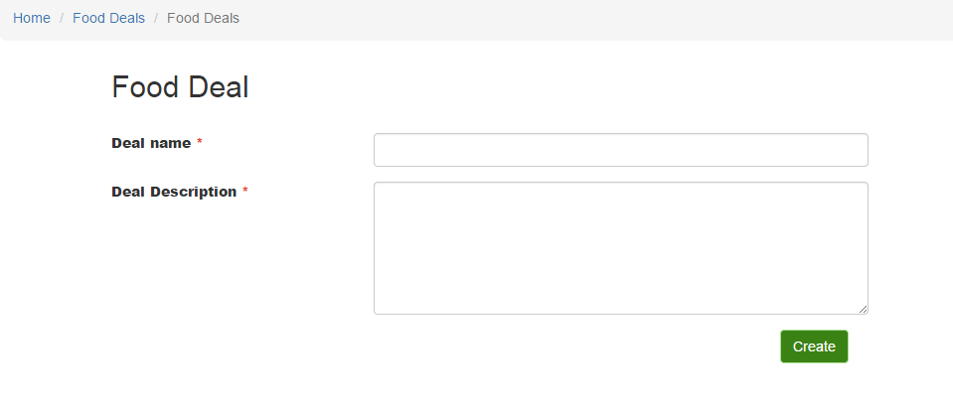

When a red asterisk is present beside the form label, this means that the form field or text box cannot be blank.

1. When a record is successfully created, the system will redirect to a page similar to this:

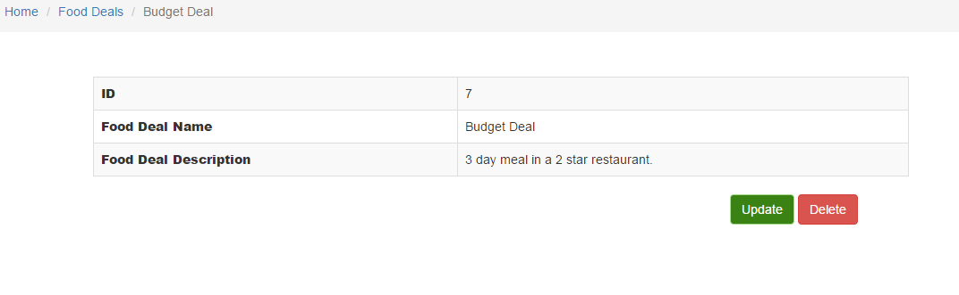

This record can also be seen in the grid table in the index page. As what is illustrated above, there are two buttons located at the bottom of the created record table. To update, simply click the update button.

To delete, click the red button labeled delete and the user will be asked for a confirmation whether they really want to delete the record. When “OK” is clicked the record will be deleted and if cancel is clicked the process of deletion will also be cancelled.

1. To update the record, change the values in the form and click update.

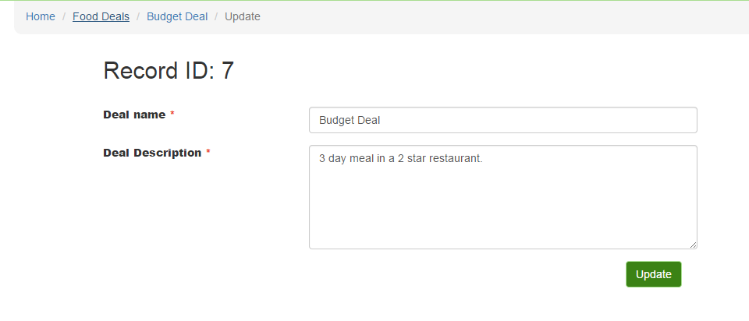

All processes can be confirmed if the changes made are seen in the grid table of records of the index page.

# Appointment Scheduler

Visa Assistance Appointment Scheduler

### Create a new Appointment

The Visa Appointment Scheduler module can be accessed by all of JMGTCC clients. The only difference is that the registered users can view the appointment in the system or through mail, while the guests can only view it through their email.

**Registered Users View**

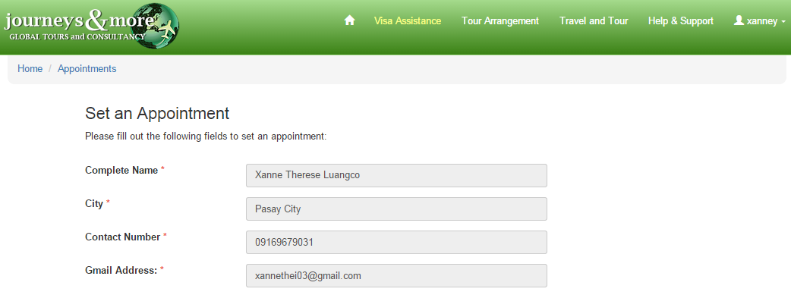

In the registered users view, the fields *“Complete Name, City, Contact Number and Gmail Address”* are already filled-up with the details of the users from the database. It cannot be edited and strictly for viewing purposes only.

### 

These fields above are the only part of the form that the user can edit

**Country:** It is the where the user could input the country where the visa would be use.

**Visa Type:** The user can choose between Immigrant and Non-Immigrant Visa.

**Appointment:** This field **must not** be blank. It is the date when the user wanted to have the visa consultation.

**Appointment Time:** This field **must not** be blank. The user can choose his desired time from all the available office hours of JMGTCC.

**Notes:** This field **can be** blank. This is where the user can add additional information or any concerns regarding his visa consultation.

**Guests View**

The guest can also set an appointment with the management of JMGTCC. It will contain the same form with what the registered users can view, but the only difference is that the fields for *Complete Name, City, Contact Number and Gmail Address* is empty and must be completely filled by the user.

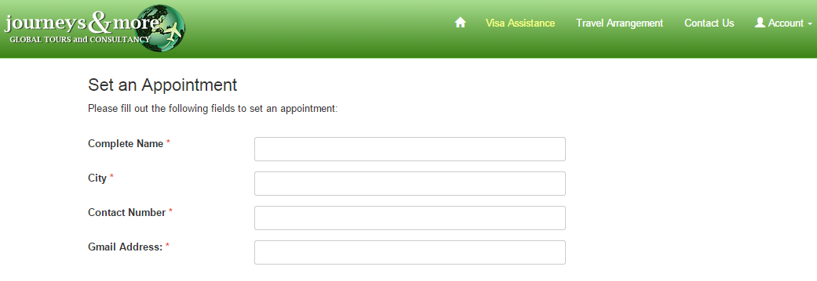

If all the required fields are answered and the “Set an Appointment” button is clicked, all the user input will be saved in the database and this view screen will be displayed.

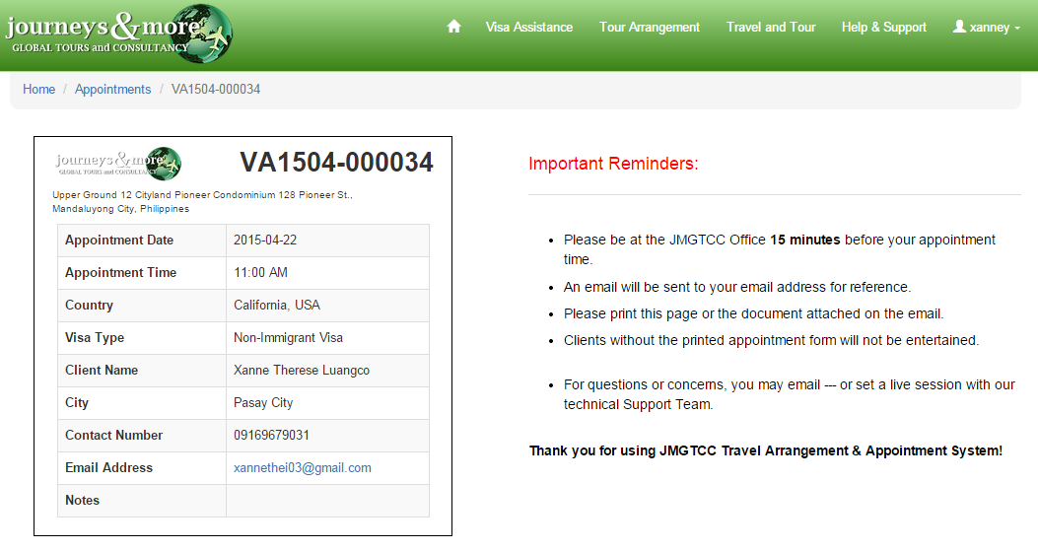

Asi

Aside from this view form, the user will also receive a mail regarding his visa consultation appointment, which contains the appointment code and all the details that he input to the system.

### 

Once the visa consultation appointment is made, the user can no longer update it. If there are multiple appointments made by the same user, all previous appointments would be considered as **“Cancelled”** and only the latest appointment would be credited.

### Confirmation of Appointment (Backend)

All the appointments made by JMGTCC clients can be viewed by the admin/encoder. They are the ones who are responsible to confirm the appointments made by the clients and generate the fixed consultation fee.

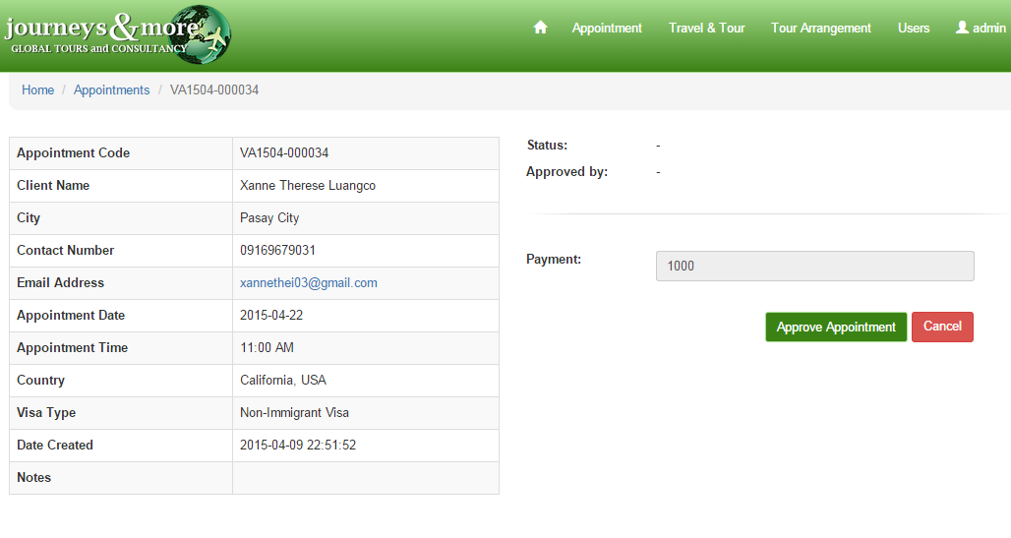

In this page, the admin/encoder can click the “Approve Appointment” button, to confirm that the client arrived on schedule.

**Payment:** The admin can’t edit this value and for viewing purposes only.

After an appointment is APPROVED, the admin can no longer update or edit that specific appointment and the status of that appointment will be set as “CONFIRMED”

# Travel & Tour Arrangement

### Create Travel & Tour Arrangement

This module can only be accessed by registered users. This is where the users are given the chance to choose their desired travel arrangements, either by selecting from the options provided or by user input. It is subdivided into these two parts:

* **Tour Arrangement**

This was for user who only wanted to avail the tour package of JMGTCC. When the user selected this option, the travel agency will assume that the user already have a plane ticket or the plane tickets won’t be included in the package.

The following are the details that the user must fill-up:

* Travel Details

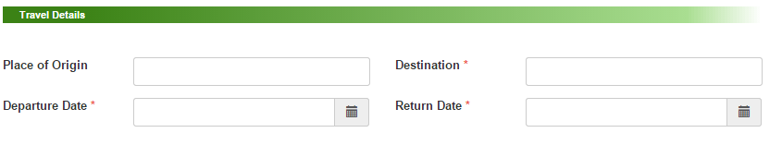

**Place of Origin:** If left blank, the value that will be saved is *“Manila, Philippines”*

**Return Date:** This should be the date after the selected departure date, otherwise a message box will be displayed and the user input will be deleted.

**The fields with a red asterisk (*) are required and the user must fill it up completely.**

* Accommodation
* 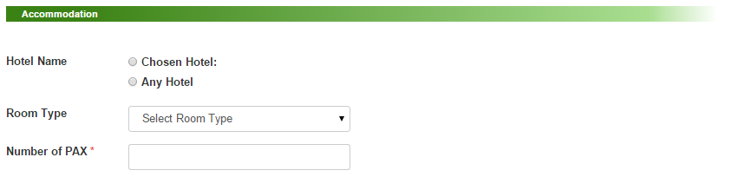

Hotel N

**Hotel Name:** If *“Chosen Hotel”* is clicked, a textbox will automatically appear. This is where the hotel name that the user desires can be entered.

* Tour and Transport

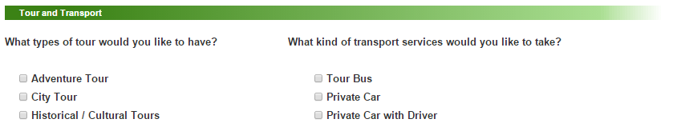



**If the user will not select any option, the default value would be all available options**

* Inclusion

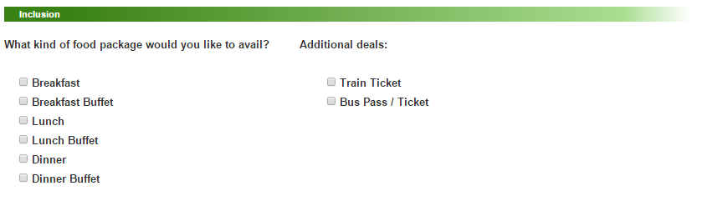

**If the user will not select any option, the default value would be all available options**

* Others

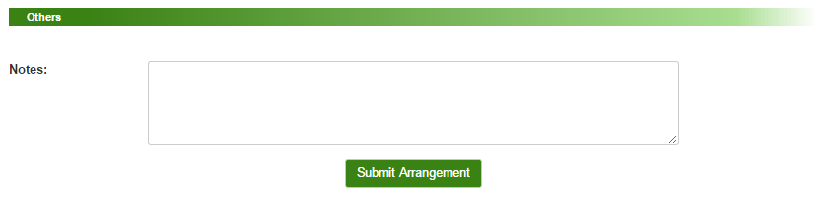

**Notes:** This field is optional. If no value was entered the default value is also empty.

* **Travel and Tour Arrangement**

When the user selected this option, the travel agency will assume that the user will avail both the travel and tour arrangement package deal. The only difference between this option from the Travel Arrangement is that it has an additional field called *“Flight Information.”*

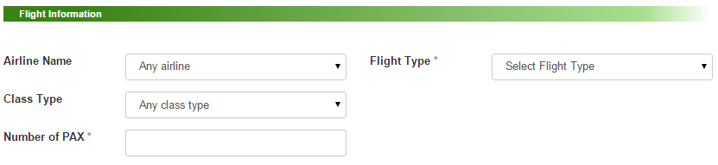

**The fields with a red asterisk (*) are required and the user must fill it up completely.**

After all the user clicked the “Submit Arrangement” button, all the data entered will be saved in the database and at the same time, the travel agents of JMGTCC will also receive an email about the user’s tour arrangement. The final transaction and travel deal between the user and JMGTCC will be in mail.

### Viewing of Arrangement Made (Backend)

The management can view all the travel and tour arrangements of their clients in the Backend of the system. This is the only option that the admin could do to this module.

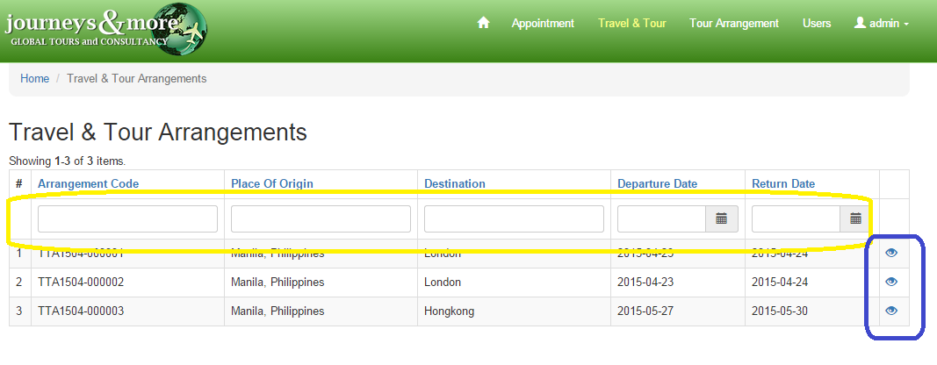

* The **search field** in yellow mark can be used by the admin to search for the specific travel arrangement of a client.
* If the admin/encoder wanted to view all the details about a certain tour arrangement, it can be done by simply creating the eye icon, which was in blue mark on the side.

# Customer Service

### Connecting to a live agent

Live chat support is available anywhere in the frontend or the client page. To start a conversation with the operator or the support, follow the steps below:

1. Click the chat box located at the lower right of the screen. The box will automatically pop out and will inform you if there are any online operators but offline operators doesn’t mean you cannot start a conversion you may still proceed with your inquiries.
2. Enter your name
3. Start chatting.

Here is a sample screenshot of the live chat support:

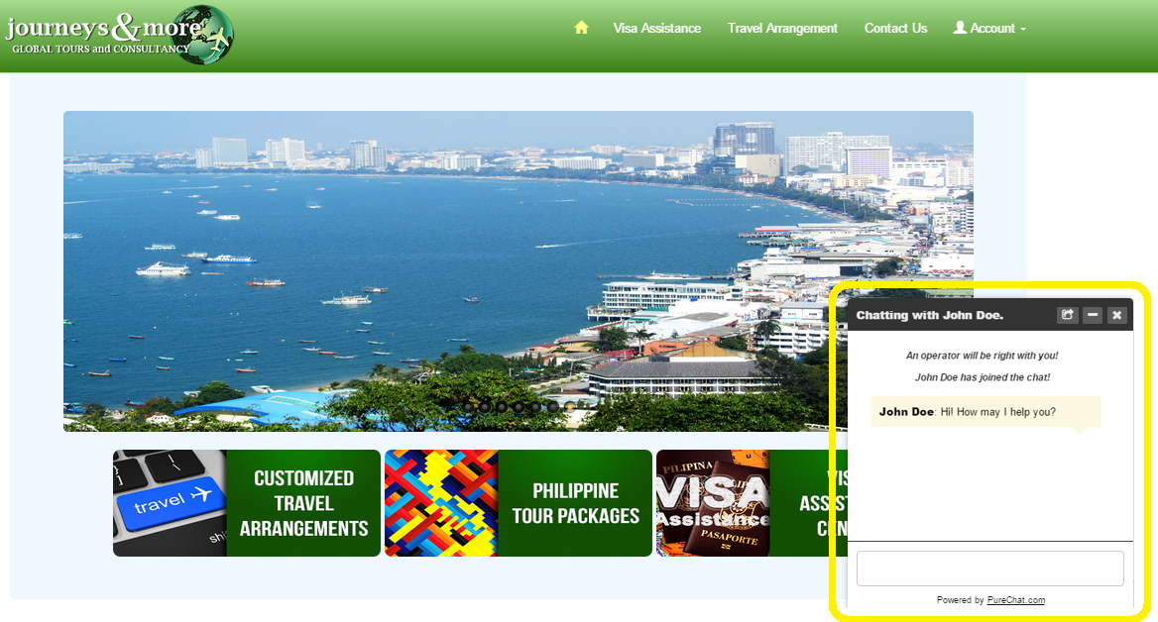

Here is another way to connect to a live agent but this time through a private chat message. To start simply click one of the operators as shown in the image below:

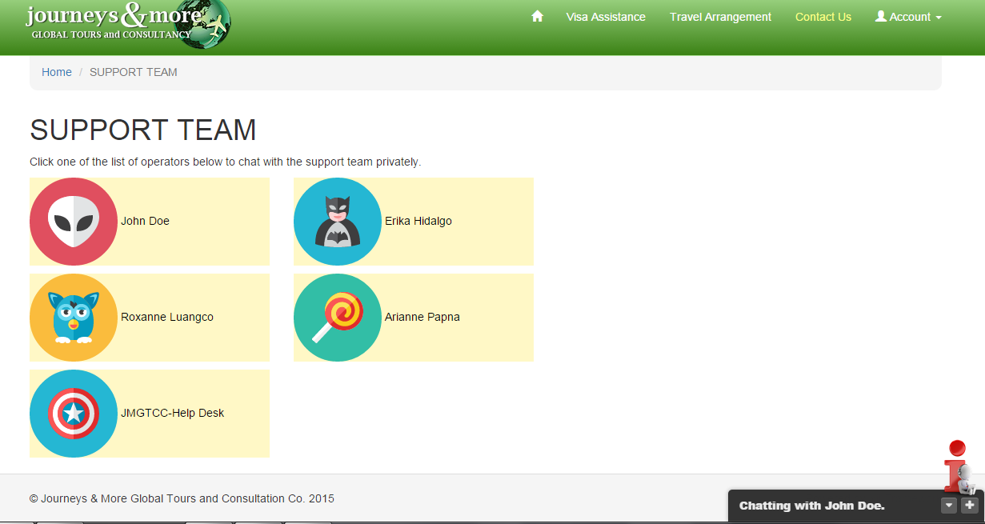

After clicking one of the operators in this case operator John Doe, you will be redirected to a new website.

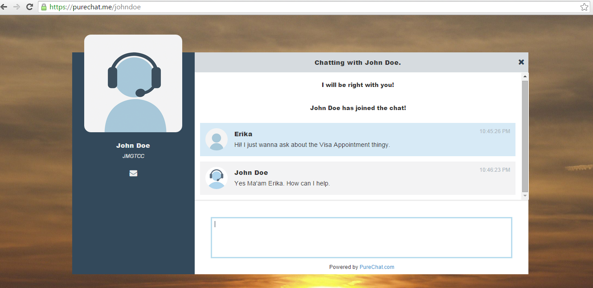

The process is still the same with regards to starting a conversation. You simply have a more private experience with the operator and a bigger layout of the chat box.

### The agent’s perspective

This is the view of the agent handling the inquiries, as what is shown in the image below, the conversion that is currently ongoing can be seen in the middle and incoming chats is situated in the upper left of the site.

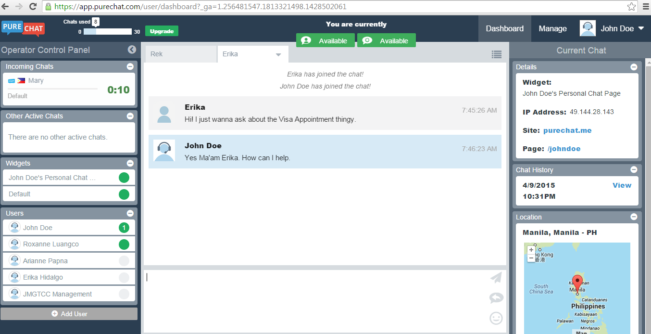

Other operators who you can team up with can be seen in the lower left part called the “Users” tab. As what is shown in the image users or operators that are online is marked green, if it doesn’t have the green orb beside their name then it only means that the operator is online.

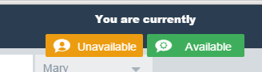

In the upper center of the screen you may see two floating buttons that are orange at start. If the button is orange then it currently means that you as an operator is unavailable but if it is green then you are available for conversation. The two buttons are for the private chat or the personal chat and the default widget of the website.

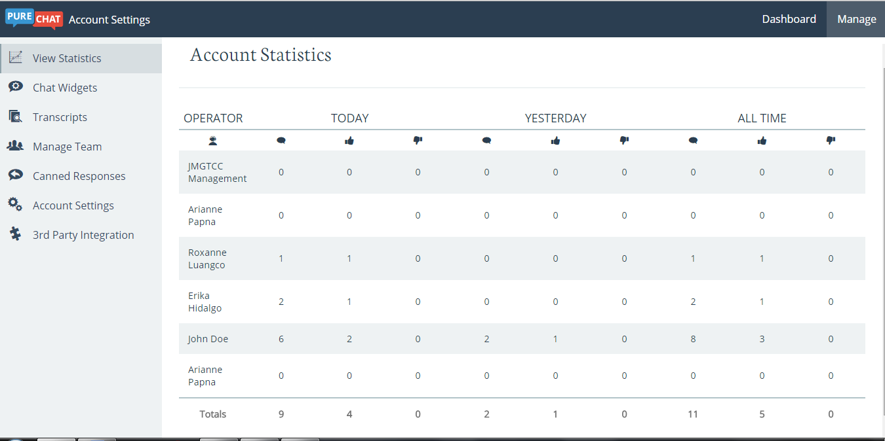

If the operator is an admin, the operator can track all the users or members of the team as what is shown in the table above. The more the thumbs up an operator have, the better their performance